June 25th, 2006
Leonie, Gavin and Nadine
The letter will probably be a bit shorter this time.
H5N1 is in the news again. The New England Journal of Medicine published an article from doctors in China reporting that a patient who supposedly died of SARS several years actually died of the H5N1 bird flu virus. Both were detected in his body. They suspect that the H5N1 virus originated about the same time as the SARS virus, though how this is possible I do not know as I thought the 1918 ‘Spanish flu’ virus was of the H5N1 type.
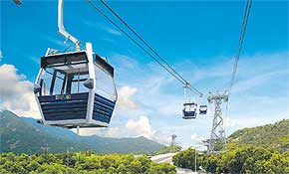
Last Monday a catamaran ferry from HK collided with a small cruise ship collide off Macau. One of the vehicles, I am not sure which, seemed to be sinking with people jumping into the water. However, nobody was seriously hurt. You have probably heard of the new Lantau cable-car system from Tung Chung (near the airport) up to the big Buddha. It was supposed to have been opened yesterday but it had to be cancelled as they are still having problems getting it to work properly. The other day it broke down with about 500 people (there for a free trial ride) left stranded in the cars for a couple of hours.

Wounds are healing quite well. The skin grafts no longer need dressings and although the hospital still puts dressings on my hand, I often take them off. I go to the gym now without hand dressings. Still have the foot dressing, as that was the biggest wound. I hope I can stop going to the hospital soon. I am supposed to go every day for dressings but only go three days a week.
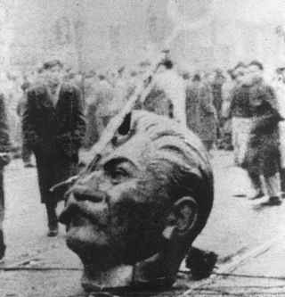
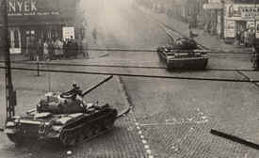
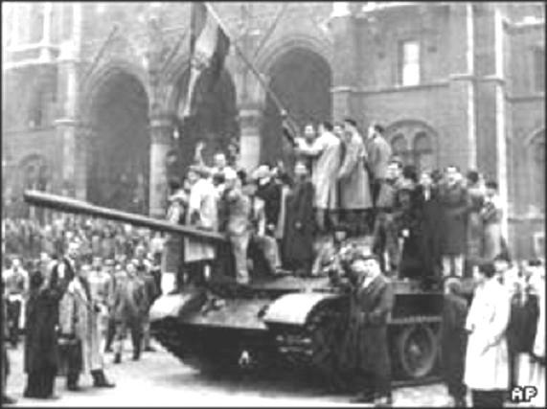
Another anniversary. This is for the Hungarian uprising 50 years ago against the Russians, which is actually in October but part of it was celebrated this past week, as Bush happened to be there. Snipers in buildings and unarmed people took on the Russian tanks sent in to quell the uprising. The photos show Soviet tanks in the streets of Budapest, Hungarian ‘freedom fighters’ forcing back a Russian tank and the remains of a statue of Stalin. I remember it quite well in spite of us not having TV then. It occurred just before the 1956 Olympic Games in Melbourne. Many of the Hungarian team sought political asylum while at the Games. There was also a lot of tension between the Hungarian and Soviet teams. This boiled over in the water polo competition when both these countries got into the final. It was an extremely viscous game.
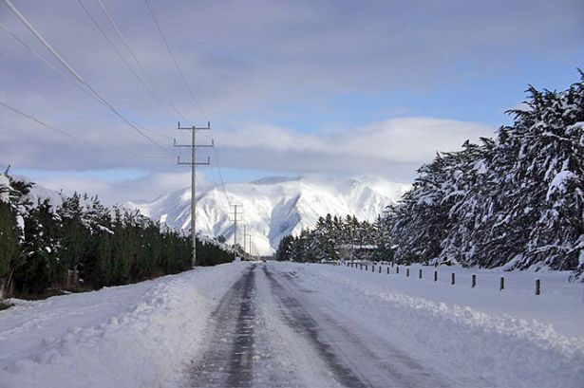
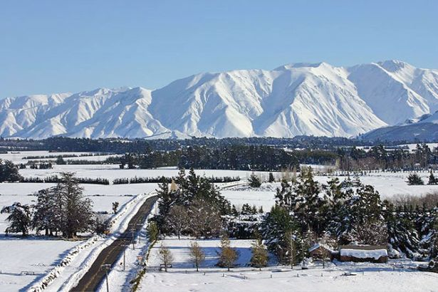
NZ blanketed in snow again, the second icy blast in 11 days. Snow everywhere, even over in sunny Gisborne where I came from and never ever saw snow in the city. However, there is plenty of snow on the snowfields, which will be having the best season opening ever, it seems. Pictures show snow on the Canterbury plains looking towards the Mt Hutt ski fields.

Back in HK, its now a year since Donald Tsang became the new CE and in a speech said that he would be doing more direct consultation with the individual man-in-the-street in the coming year. He has not done that much in the past year except perhaps to give people more confidence in the government. But the thing he has done, in spite of a lot of opposition, it to get approval from the Legislative Council for a new HK$5.2 billion government headquarters to be built of the former HMS Tamar waterfront site to replace the existing building in Cotton Tree Drive (near the US Consulate). Many people and organisations wanted the Tamar site to be used for public parks.
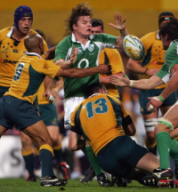
HK has been getting some very hot weather in the past few days. Yesterday, the temperature reached about 35⁰C around here and 40⁰C at Repulse Bay!

Australia beat Ireland 37-15 in a one-off test in Perth. The All Blacks are in Argentina for one match against the Pumas – won 25-19. France beat the Springboks in SA.
From your graduation photos, Leonie, I have one question. As you said, you only had two tickets for guests to the ceremony, which two of those in the photos were the lucky ones? What did the others do?
That is it for now.

Cheers

